**B. Tech. Project Part-1 (COC4980) Report on Assignment-II**

**LITERATURE REVIEW**

REAL TIME OBJECT DETECTION APPLICATION FOR VISUALLY IMPAIRED

SUBMITTED IN PARTIAL FULFILLMENT OF THE REQUIREMENTS

FOR THE AWARD OF THE DEGREE OF

**Bachelor of Technology**

IN

**COMPUTER ENGINEERING**

BY

|  |  |
| --- | --- |
| **Mohammad Saim**  **20COB070** | **Rehma Manaal Rizvi**  **20COB276** |

Under the Guidance of

**Prof. Mohammad Sarosh Umar**

**Department of Computer Engineering**

**Zakir Husain College of Engineering & Technology**

**Aligarh Muslim University**

**Aligarh (India)-202002, India**

**2023-2024**

**APPROVAL AND COMPULSORY REVIEW LIST**

|  |  |  |
| --- | --- | --- |
| **Role** | **Name** | **Date** |
| Guide/ In-charge | **Prof. Mohammad Sarosh Umar** | **06/10/2023** |

**VERSION CONTROL**

|  |  |  |  |
| --- | --- | --- | --- |
| **Date** | **Version** | **Comments** | **Author** |
| 06/10/2023 | 1.0 | FIRST DRAFT SDD | MOHAMMAD SAIM  REHMA MANAAL RIZVI |
|  |  |  |  |
|  |  |  |  |

**TABLE OF CONTENTS**

## Chapter 1

## Introduction

## Document Purpose

The purpose of this design document is to outline the Real-Time Object Detection Mobile Application for the visually impaired, emphasizing the significance of its core components: voice feedback, haptic feedback, and OCR detection.

This application is designed to empower individuals with visual impairments by providing real-time object detection and conveying information through auditory (voice feedback) and tactile (haptic feedback) means. Voice feedback ensures object identification and safety by converting visual data into spoken descriptions, facilitating navigation and object recognition. Haptic feedback complements this by offering a tactile dimension, enabling users to interact with detected objects and gain spatial awareness. Additionally, OCR detection further enhances functionality by recognizing and converting text-based information from the environment into spoken words, supporting reading, communication, and information retrieval. Collectively, these components form an inclusive and user-centric solution aimed at improving independence and accessibility for visually impaired individuals.

## Acronyms & Abbreviations

|  |  |
| --- | --- |
| Term | Definition |
| Admin | Person in-charge of the system and has the authority to push changes in the application. |
| Bounding Box | A rectangular box that encloses an object. |
| Class | It represents set of properties or methods that are common to all objects of one type. |
| Frame | A set of data with information about a particular object. |
|  |  |
| SSD | Single Shot Detector |
| OCR | Optical Character Recognition |
| YOLO | You Only Look Once |
| User | Either the visually impaired person or a helper giving video input for object detection. |
| UI | User Interface |

## Chapter 2

## Functional Modelling

2.1 Data Flow Diagram Level 0

2.2 Data Flow Diagram Level 1

2.3 Data Flow Diagram Level 2

## Chapter 3

## Behavioural Modelling

Theory of obj oriented plus 1 diagram then

3.1 STD

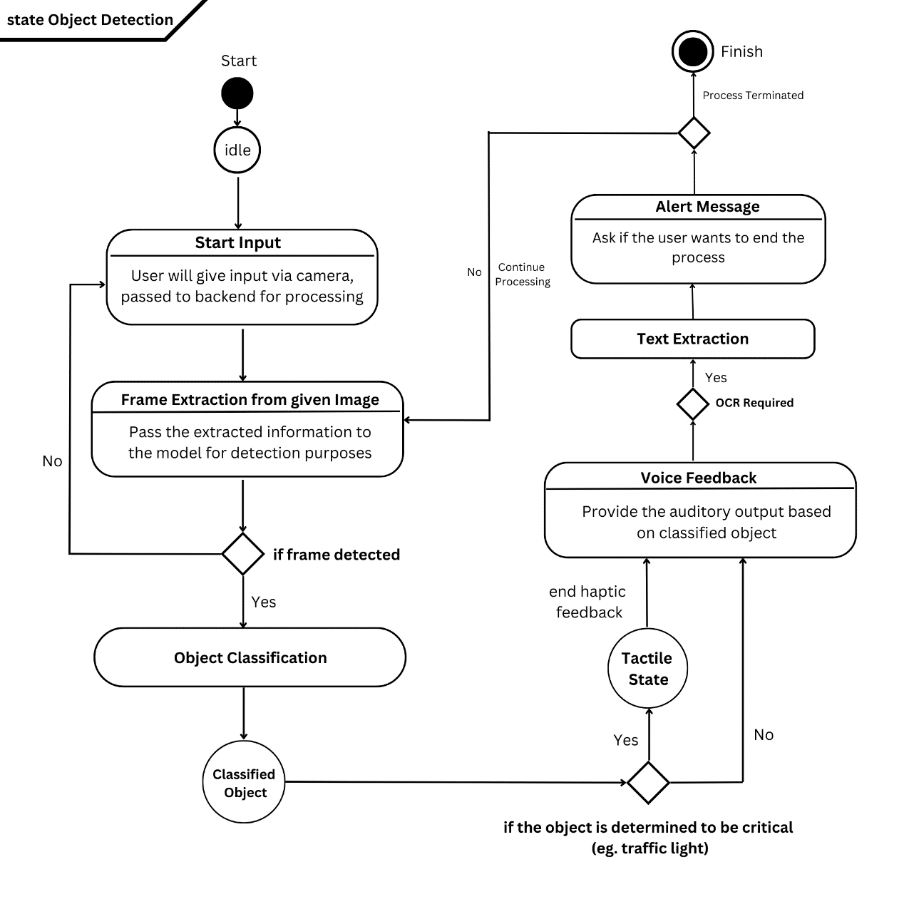

3.2 Collaboration Diagram

## Chapter 4

## Behavioural Modelling

4.1 Standard Transition Diagram

4.2 Sequence Diagram